PART 2 (60 marks = % of paper)

Answer ALL questions in Part 2 in the spaces provided below. ________________________________________________________________________

- Write equations for any reactions that occur in the following procedures. If no reaction occurs write 'no reaction'.

In each case describe in full what you would observe, including any
• colours
• odours
• precipitates (give the colour)
• gases evolved (give the colour or describe as colourless).
If no change is observed, you should state this.

(a)

Equation ________________________________________________________________

Observation ________________________________________________________________________
________________________________________________________________________
________________________________________________________________________
[3 marks]

(b)

Equation ________________________________________________________________

Observation ________________________________________________________________________
________________________________________________________________________
________________________________________________________________________
[3 marks]

(c)

Equation ________________________________________________________________

Observation ________________________________________________________________________
________________________________________________________________________
________________________________________________________________________
[3 marks]

2. For each species listed in the table below draw the structural formula, represent
all valence electrons using an appropriate symbol, and indicate the shape of the species by either a sketch or a name.

Species | Structural formula  (showing all valance electrons) | Shape  (sketch or name)
[6 marks]

3. The electron configuration of a lithium atom is 1s² 2s¹. Using the same notation, give the electron configuration of

a) ____________________________________

b) ___________________________________
[2 marks]

[6 marks]

10. Using carefully drawn diagrams, thoroughly explain the difference in shape and polarity between BF₃ molecules and PF₃ molecules.

.....................................................................................................................................................................................................

.....................................................................................................................................................................................................

.....................................................................................................................................................................................................

.....................................................................................................................................................................................................

12. Explain the difference between the terms "electronegativity" and "ionisation energy".

....................................................................................................................................................................................................

....................................................................................................................................................................................................

...................................................................................................................................................................................................
.
....................................................................................................................................................................................................

....................................................................................................................................................................................................

.....................................................................................................................................................................................................
Species | Electron dot diagram | Shape (sketch or name)
BF₃

CS₂

PCl₄⁺

How would you conduct a chemical test to distinguish between

sodium hydroxide and barium hydroxide
iron oxide and aluminium oxide
sodium oxide and sodium sulfide

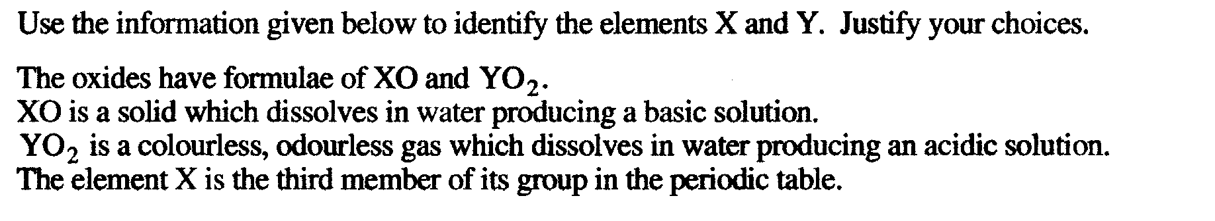
[3 marks]

_____________________________________________________________________

_____________________________________________________________________

(d) A solution of ammonium nitrate is added to a solution of potassium
hydroxide.

Equation : ..................................................................................................................................................................................

Observation : ...........................................................................................................................................................................

..............................................................................................................................................................................................................
9. Both aluminium metal and aluminium hydroxide are amphoteric.
Explain what is meant by the term “amphoteric” and write balanced equations which illustrate
the amphoteric nature of either one.

......................................................................................................................................................................................................

......................................................................................................................................................................................................

......................................................................................................................................................................................................
..

SHORT ANSWER

Question 5

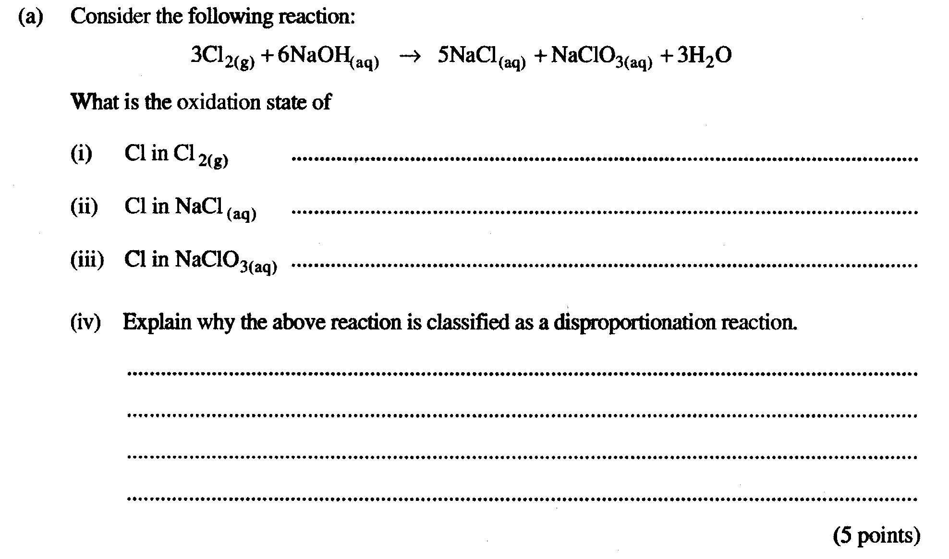
[4 marks]

____________________________________________________________

____________________________________________________________

____________________________________________________________

____________________________________________________________

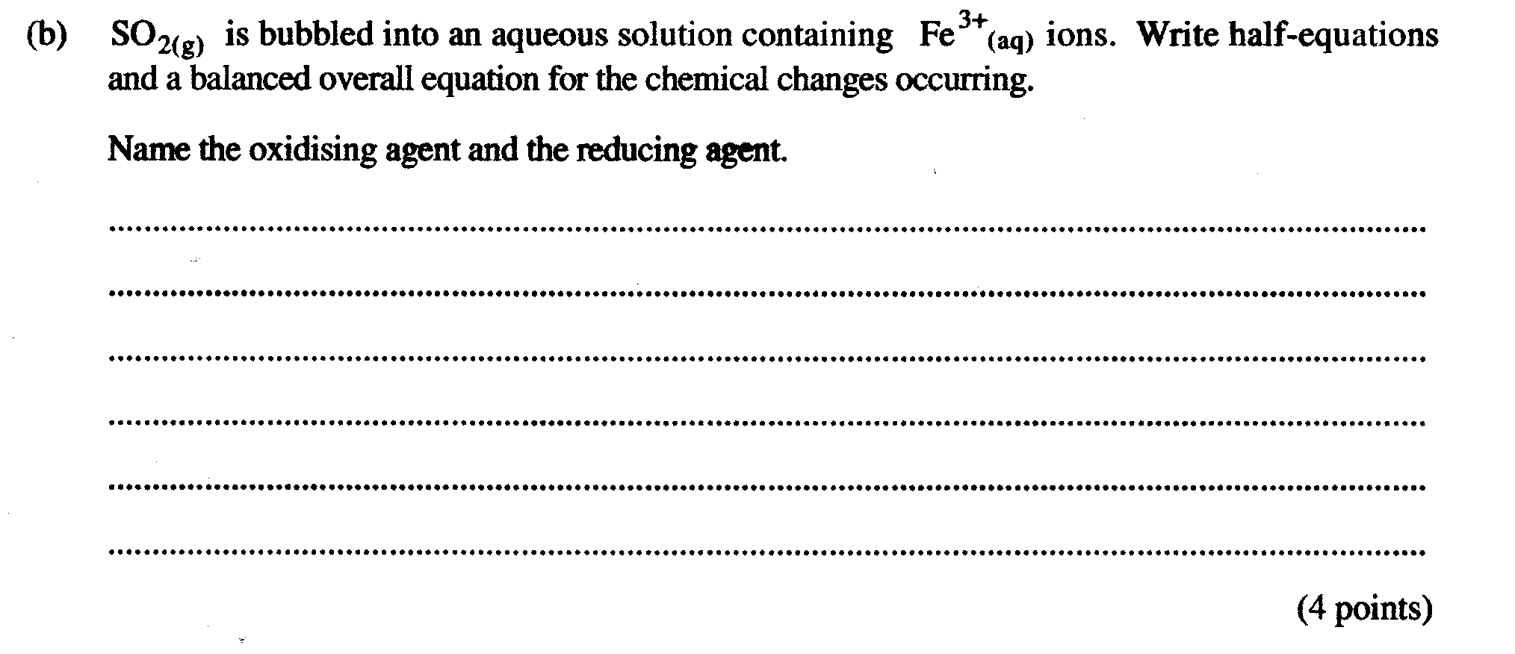
[4 marks]

_______________________________________________________________

_______________________________________________________________

_______________________________________________________________

_______________________________________________________________

_______________________________________________________________

_______________________________________________________________

(c) Copper metal is placed in a solution of lead nitrate.

Equation : ...................................................................................................................................................................................

Observation : ...........................................................................................................................................................................

.............................................................................................................................................................................................................
[3 marks]

4. Write an equation for the reaction which occurs at the cathode of a lead-acid accumulator when it is supplying an electric current.

Equation : .......................................................................................................................................................................................
[2 marks]

5. Below is a diagram of an electrochemical cell.

(b)

(a) Write a half equation to show the reaction at the anode of the cell.

...............................................................................................................................................................................................
[2 marks]

(b) Draw an arrow in the box provided on the diagram to indicate the flow of electrons in the external circuit. [1 mark]

(c) Give the formula of one ion that will move from the Mg/Mg2+ half cell towards the Ag/Ag+ half cell through the salt bridge.

........................................................................ [1 mark]

(d) Under standard conditions, what would be the maximum reading on the voltmeter in the external circuit?

........................................................................volts [2 marks]

(e) Several connected strips of magnesium and silver are used in the half-cells instead of just one strip. What would be the specific advantage of this cell over the one shown above?

Answer : ..........................................................................................................................................................................................

.................................................................................................................................................................................................................
[2 marks]

[6 marks]

11. Consider the electrolysis of molten potassium iodide and 1.0 mol L⁻¹ potassium iodide solution.
Write the equations for the anode and cathode reactions in each case.
(a)

KI(l)

Anode:

Cathode:

(b)

KI(aq)

Anode:

Cathode:

[4 marks]

(d) Nickel pellets are dropped into a warm solution of chromium(III) nitrate.

EQUATION: ___________________________________________________________________________

OBSERVATION: _______________________________________________________________________
[2 marks]
- Three experiments were performed by passing electricity through different electrolytes using different electrodes. The electrolytes and electrodes used are shown in the table below. Complete the table by writing the oxidation and reduction half equations which are most likely to occur at the anode and cathode.

Expt  No. | Electrolyte | Electrodes | Half-reactions at:
Expt  No. | Electrolyte | Electrodes | cathode | anode
1 | 1 mol L⁻¹ CuSO₄(aq) | carbon
2 | KBr(l) | platinum
3 | A mixture of  1 mol L⁻¹ AgNO₃(aq) and  1 mol L⁻¹ Cd(NO₃)₂(aq) | platinum

4.

5.

6.

[4 marks]
7.

[4 marks]

[4 marks]

[4 marks]

8.
[2 marks]

9.

[4 marks]

[3 marks]

11.

12.

13.

[6 marks]

